1. **Explain nested IF conditions?**

Answer: IF() is used when one condition needs to be tested and only 2 respective outputs needs to be displayed, nested IF() is used when more than 2 conditions needs to be checked with displaying respective output for each condition.

IF formula identifies a given condition is met or not, there are common needs that a given data has more than two outcomes.

Example: I have data of average time taken to resolve a complaint in the column A & I want to know if the time taken was within the group of 4 different times ( 2 , 4, 6 & Greater than 6). Single IF will tell if the value is within a single point i.e., within 2 or beyon, to increase this we test the same value with the help of operators. The formula would look like =IF(A2<=2,"2 hours",if(A2<=4,"4 hours",if(A2<=6,"6 hours",">6 hours"))).

1. **What is Name manager, give a used case?**

Answer: Name manager is a collection of a fixed data. By dedicating a name to a series of cells, we can refer them directly by using the created name and avoiding going to the actual data location. This helps us to maintain a standard fact table and helps reduce error reduction.

Example: I am asked to get employees contact number which exists in the employee_data base sheet and map it to their attendance sheet. To perform this activity, one may choose to do VLOOKUP, the fact table would look like employee_data!A1:A101 (assuming there are 100 employees), we can avoid the address mentioned before instead create a name for this location like "edb" for the same range. This simple change can keep all the important data points handy. To create a name to a given location you must go to the name manager from ribbon or press the short key Ctrl + F3.

1. **What is the use of a table? How to create a table?**

Answer: Tables help group data into a structured format. Table can be created to any range, simply by pressing Ctrl + T, excel identifies the active range as a table.

* The created table will have dedicated labels(headers) on the top with a filter enabled by default.
* Tables have the auto sum for a series of numbers by default, which can modify to other numerical aggregation or even disable it
* Table to get auto filled vertically and horizontally. Imagine if a table is consisting timestamp in the first column and about 10 more columns having other data points, if I want only date in the 12the column; I would be writing single formula in the first row of column 12 and the rest will be auto filled including the formatting. Very similarly if we add new data in the new empty rows which is after the last row from a table, the added data appends to the current table with all the formatting.
* Since these are named as tables, any corresponding values will update automatically in case of a formula & in case of a pivot; one must refresh the pivot to update the new changes.

1. **Explain the combination of IF with other formulas?**

Answer: IF function can be used to test more than one condition in a single IF clause, I will only have to add more formulas to it like an AND condition otherwise I can also use OR, I can also use a combination of both.

The parenthesis, commas must be placed well else the calculations may be incorrect.

1. **We have list of users who have their names with prefixed with Mr. Mrs. You are asked to show a summary of contribution of married an unmarried. How will you achieve this?**

Answer: To classify this data will have to use a combination of multiple functions. We will have to find Mrs first if found we mark it as Mrs else we search for Mr then mark it as Mr. =IF(ISERROR(FIND("Mrs",NAME,1)),IF(ISERROR(FIND("Mr",NAME,1)),"Neither Mrs nor Mr.","Mr"),"Mrs"). To once we get the result, we can create a pivot to know the count, take the contribution of grad total; apply this as pie chart.

1. For an IF function to check whether cell B3 contains a value between 15 and 20 inclusively, what condition should you use?
   1. OR(B3=>15,B3<=20)
   2. **AND (B3>=15,B3<=20)**
   3. OR(B3>15,B3<20)
   4. AND(B3>15, B3<20)
2. Which two functions check for the presence of numerical or nonnumerical characters in cells?
   1. **ISNUMBER and ISTEXT**
   2. ISNUMBER and ISALPHA
   3. ISVALUE AND ISNUMBER
   4. ISVALUE and ISTEXT
3. . When editing a cell, what do you press to cycle between relative, mixed, and absolute cell references?
   1. Alt+F4 (Windows) or Option+F4 (Mac)
   2. Alt+Shift+4 (Windows) or Option+Shift+4 (Mac)
   3. Ctrl+Shift+4 (Windows) or Command+Shift+4 (Mac)
   4. **the F4 (Windows) or Command+T (Mac)**
4. . Which function returns TRUE if cell A1 contains a text value?
   1. =ISALPHA(A1)
   2. =ISCHAR(A1)
   3. =ISSTRING(A1)
   4. **=ISTEXT(A1)**
5. . You are determining % growth by dividing Growth by Sales. Which Excel function would you use to avoid #DIV/0! errors?

[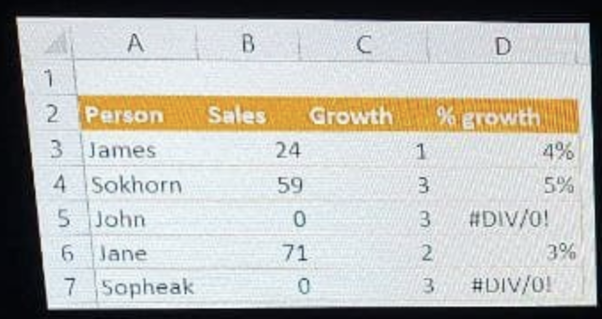](https://github.com/Ebazhanov/linkedin-skill-assessments-quizzes/blob/main/microsoft-excel/images/Q102.png?raw=png)

* 1. **IFERROR**
  2. ROUND
  3. ISERROR
  4. DIVIDE

1. [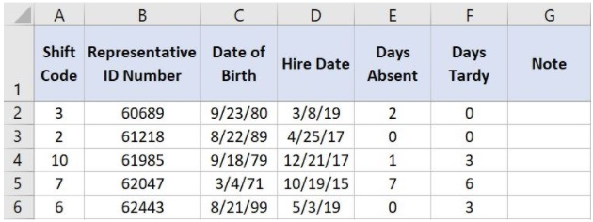](https://github.com/Ebazhanov/linkedin-skill-assessments-quizzes/blob/main/microsoft-excel/images/Q104.jpg)Which value is returned when you enter this function into cell G2? =IF(SUM(F2:F6)>12,"Too Many Tardy Days","No Tardiness Issue")
   1. Too Many Tardy Days
   2. #NUM!
   3. **No Tardiness Issue**
   4. #REF!

Note:- 0 + 0 + 3 + 6 + 3 = 12. The formula only dislays "Too Many Tardy Days" when it is more than 12.

1. Which of the following functions would return the phrase “You win!” if B6 held the value 29?

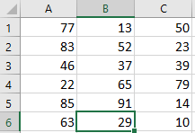

* 1. =IF(B6=29,”Try again!”,”You win!”)
  2. =IF(AND(B6=29,C6=15),”You win!”,”Try again!”)
  3. **=IF(OR(B6=29,C6=15),”You win!”,”Try again!”)**
  4. None of the above

1. NOT, AND, OR and XOR are
   1. A Arithmetic operators
   2. B Relational operators
   3. **C Logical Operators**
   4. D None of the above
2. You are editing a worksheet that you had previously saved. If you want to save the edited sheet without losing the original one, which command should you use ?
   1. A Save
   2. **B Save As**
   3. C Both (A) and (B)
   4. D None of the above
3. Which of the following is correct syntax in Excel ?
   1. A =IF(LogicalTest, TrueResult), IF(LogicalTest, FalseResult)
   2. B =IF(LogicalTest, TrueResult) (LogicalTest, FalseResult)
   3. C =IF(LogicalTest, (TrueResult, FalseResult))
   4. **D =IF(LogicalTest, TrueResult, FalseResult)**